Yeezus Operating System
Software Requirements Specification

Version 1.0

Revision History
Date | Version | Description | Author
<dd/mmm/yy> | <x.x> | <details> | <name>

Table of Contents
1. Introduction 4
2. Overall Description 4
3. Specific Requirements 5
3.1 The Memory System 5
3.1.1 Registers 5
3.1.2 RAM 5
3.1.3 Disk 6
3.2 The Driver Overview 6
3.2.1 The Driver 6
3.2.2 Loader 6
3.2.3 Scheduler 7
3.2.4 Dispatcher 7
3.2.5 Memory 7
3.2.6 Effective-Address 8
3.2.7 Fetch 8
3.2.8 Decode 8
3.2.9 Execute 8
3.3 CPU 8
3.3.1 DMA-Channel 9
3.3.2 ComputeOnly 9
3.4 Design Constraints 10
3.4.1 <Design Constraint One> 10
3.5 On-line User Documentation and Help System Requirements 10
3.6 Interfaces 10
3.6.1 User Interfaces 10
3.6.2 Software Interfaces 10
3.7 Applicable Standards 10
4. Supporting Information 11

Software Requirements Specification

Introduction
The following is the Software Requirements Specification document our group will use for the series of projects for the CS3502, Operating Systems, class at Kennesaw State University for the Spring 2018 semester under the guidance of our professor, Dr. Patrick Bobbie. Throughout the course of this document, any instructions specified by Dr. Bobbie will be displayed in this font, to help differentiate from our group’s work. Additionally, there are several provided graphics or pseudocode which are in figures, and these will be indicated within the figure description.
This project has been broken into 2 phases consisting of 2 parts each. Although the parts and phases are not

Overall Description
The semester course project is on the design and implementation of an OS simulator. The project is divided into two phases. Each Phase has two parts. The requirements are discussed below.
In this semester long project, you are required to design and implement a complete virtual machine, with its own virtual CPU and a control system (or Operating System), together making a Simulator. The given tasks, or user programs/processes, will run on the virtual CPU. The CPU’s architecture and instruction repertoire are posted in the Instruction Format and Instruction Set files in the Project Folder. You will design and implement a number of program modules in a high-level language of your choice, e.g., Java, C, C#, to complete this OS Project.

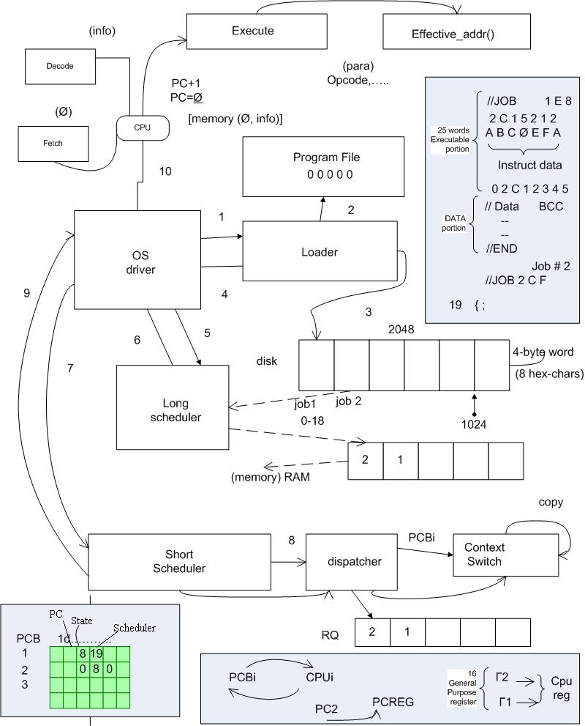
Figure 1 Overview of the Operating System components (provided by Dr. Bobbie).

Specific Requirements

The Memory System
The memory hierarchy comprises a set of simulated registers, a program/data simulated RAM, called memory and a simulated hard drive called disk. The contents of the disk and RAM are hex characters; and of sizes 2048 and 1024 words, respectively. (Each word is 4 bytes or 8 hex characters long.)


Figure 2 Overview of the memory system.

Ancillary programs to dispatch processes/programs from disk to RAM, to compute effective addresses, to access memory, to fetch instructions and decode instructions will also be needed. Additional support programs for conversions between hex, decimal, and binary numbers will be necessary.

ID: Memory Requirement (MR) 1
TITLE: Registers
DESC: The system must have 16 registers of 32-bits each.

ID: MR 2
TITLE: RAM
DESC: The system must be able to store 1024 words in RAM.

ID: MR 3
TITLE: Disk
DESC: The system must be able to store 2048 words on the disk.

The Driver Overview
The OS driver constitutes the core, or the main thread, of the simulator. Its function is to simply call the loader to load user programs, or jobs, which are already assembled (given as a stream of hex character) and stored in a ‘program-file.’ The program-file, named as DataFile, is in the Project Folder as well. The Driver calls the Scheduler to select a user program from a list of ‘ready’ jobs for dispatch. The Dispatcher places the selected job or program in an ‘execution context’ to run on the virtual CPU. The CPU executes the programs in the simulated RAM. Generally, if a program/job is interrupted while on the CPU, the interrupt is serviced while the job is suspended. After the service is done, the job must be returned to the ‘ready-state’, at some point in time. When a program completes, the Scheduler and the Dispatcher process the next program. This cycle continues forever or until your simulator is shut down when no more user programs are pending.
The following program sketch should help you design and implement the Driver module (for a single batched system):
Driver {
loader();
loop
scheduler();
dispatcher();
CPU();
waitforinterrupt();
endloop;
}
Figure 3 Overview of the Driver's actions (provided by Dr. Bobbie).

Driver
ID: Driver Requirement (DR) 1
TITLE: Driver
DESC: The System must have a Driver to loop through system processes.

ID: DR 2
TITLE: Driver Load
DESC: The Driver must be loaded and executed at system boot.

ID: DR 3
TITLE: Call the Loader
DESC: The Driver must call the loader before the loop.

ID: DR 4
TITLE: Call the Scheduler
DESC: The Driver must call the Scheduler.

ID: DR 5
TITLE: Call the Dispatcher
DESC: The Driver must call the Dispatcher.

ID: DR 6
TITLE: Execute Process
DESC: The Driver must execute the scheduled process.

ID: DR 7
TITLE: Handle Interrupts
DESC: The Driver must handle any interrupts.

ID: DR 7.1
TITLE: Handle _________ Interrupts
DESC: _______________________________

ID: DR 8
TITLE: Driver Loop
DESC: The Driver must loop through calling the Scheduler, calling the Loader, executing the process, and handling interrupts.

ID: DR 9
TITLE: Shutdown
DESC: ________________________

Loader
The loader module opens (once at the start) the ‘program-file’ and performs the loading process. Programs are loaded into disk according to the format of the batched user programs in the program-file. Ancillary programs would be needed to process (strip off) the special control “cards” – which start with ‘//’. For example, the ‘// Job 1 17 2’ control card of Job1 is processed by discarding the ‘//’, noting that the ‘1’ is the ID: of the first job, noting that ‘17’ (or 23 in decimal) is the number of words that constitute the instructions of Job 1, and ‘2’ is the priority-number (to be used for scheduling) of Job 1. All the numbers are in hex. Following the Job-control card are the actual instructions – one instruction per line in the program-file, which must also be extracted and stored in disk.
Similar logic for processing the data-section, following the instructions and proceeded by ‘// Data …’ control cards, also applies. In the case of Job 1, for example, ‘// Data 14 C C’, means Job 1’s input buffer is 20 (14 in hex), its output buffer size is 12 (C in hex) words, and the size of its temporary buffer is 12 (C in hex) words. (In this simulation, the input buffer comes pre-loaded with the input data, for simplicity.) All the data values on the control cards are attributes of each program, must be extracted and stored in the Process Control Block (PCB) (see below).
The basic outline of the loader’s logic looks like the following:
while (not end-of-program-data-file) do {
Read-File();
Extract program attributes into the PCB
Insert hex-code or instructions into the simulated RAM
}
Figure 4 Outline of the loader’s logic (provided by Dr. Bobbie).

ID: Loader Requirement (LR) 1
TITLE: Read Files
DESC: The Loader must read files as Strings from the Program-File.txt file.

ID: LR 1.1
TITLE: Read Cards
DESC: The Loader must read control data from any line of the source file which begins with “//”.

ID: LR 1.1.1
TITLE: Read Cards – Job #
DESC: The Loader must retrieve the Job # from the cards in the source file.

ID: LR 1.1.2
TITLE: Read Cards – Job Length
DESC: The Loader must retrieve the Program Length (written in hex) from the source file.

ID: LR 1.3
TITLE: Read Cards – Job Priority
DESC: The Loader must retrieve the Job Priority (written in hex) from the source file.

ID: LR 1.1.4
TITLE: Read Cards – Data Input Buffer
DESC: The Loader must retrieve the Data Input Buffer (written in hex) from the source file.

ID: LR 1.1.5
TITLE: Read Cards – Data Output Buffer
DESC: The Loader must retrieve the Data Output Buffer (written in hex) from the source file.

ID: LR 1.1.6
TITLE: Read Cards – Data Temporary Buffer
DESC: The Loader must retrieve the Data Temporary Buffer (written in hex) from the source file.

ID: LR 1.2
TITLE: Read Data
DESC: The Loader must read Words from the source file.

ID: LR 1.2.1
TITLE: Read from String
DESC: The Loader must read the data as hex written in Strings. Ex: “0x01234567” (one Word per line).

ID: LR 2
TITLE: Load to Disk
DESC: The Loader must load the programs from the file into the disk.

ID: LR 3
TITLE: Read Sequence
DESC: The Loader will first read the Control Card, the instructions, The Data Card, then the data for each program.

ID: LR 4
TITLE: Annotate PCB
DESC: The Loader must fill in data to the PCB as it loads programs.

ID: LR 4.1
TITLE: Annotate PCB –
DESC:

Scheduler
The Scheduler loads programs from the disk into RAM according to the given scheduling policy. The scheduler must note in the PCB, which physical addresses in RAM each program/job begins, and ends. This ‘start’ address must be stored in the base-register (or program-counter) of the job). The Scheduler module must also use the Input/Output buffer size information (extracted from the control cards) for allocating spaces in RAM for the input and output data. It may be instructive to store the start addresses of the input-buffer and output-buffer spaces allocated in RAM as well. (Note that a job’s program-counter, which is a component of the PCB, is different from the virtual CPU’s program-counter – see below). The Scheduler module either loads one program or multiple programs at a time (in a multiprogramming system). Thus, the Scheduler works closely with the Memory manager and the Effective-Address method to load jobs into RAM.

ID: Scheduler Requirement (SR) 1
TITLE:
DESC:

Dispatcher
The Dispatcher method assigns a process to the CPU. It is also responsible for context switching of jobs when necessary (more on this later!). For now, the dispatcher will extract parameter data from the PCB and accordingly set the CPU’s PC, and other registers, before the OS calls the CPU to execute the job.

ID: Dispatcher Requirement (DiR) 1
TITLE:
DESC:

Memory
This method is the only module of your simulator by which RAM can be accessed. A known absolute/physical address must always be passed to this method. The Memory simply fetches an instruction or datum or writes datum into RAM (or cache – more on this later!).

ID: MR 4
TITLE:
DESC:

Effective-Address
This method takes a logical address and returns the corresponding absolute/physical address for the calling unit (e.g., the CPU). The Effective-Address method also supports the Fetch and Decode methods – a part of the CPU, during instruction fetch-decode-execute cycle. The Effective-Address supports two kinds of address translations – direct and indirect, using the index register.
The basic steps for calculating the effective addresses are:
direct addressing: EA = C(base-reg)+ D; // D is the 16-bit offset or displacement
indirect addressing: EA = C(base-reg) + C(I-reg) + D;

ID: Effective-Address Requirement (ER) 1
TITLE:
DESC:

Fetch
With support from the Memory module/method, this method fetches instructions or data from RAM depending on the content of the CPU’s program counter (PC). On instruction fetch, the PC value should point to the next instruction to be fetched. The Fetch method therefore calls the Effective-Address method to translate the logical address to the corresponding absolute address, using the base-register value and a ‘calculated’ offset/address displacement. The Fetch, therefore, also supports the Decode method of the CPU.

ID: Fetch Requirement (FR) 1
TITLE:
DESC:

Decode
The Decode method is a part of the CPU. Its function is to completely decode a fetched instruction – using the different kinds of address translation schemes of the CPU architecture. (See the supplementary information in the file: Instruction Format.) On decoding, the needed parameters must be loaded into the appropriate registers or data structures pertaining to the program/job and readied for the Execute method to function properly.

ID: Decode Requirement (DeR) 1
TITLE:
DESC:

Execute
This method is essentially a switch-loop of the CPU. One of its key functions is to increment the PC value on ‘successful’ execution of the current instruction. Note also that if an I/O operation is done via an interrupt, or due to any other preemptive instruction, the job is suspended until the DMA-Channel method completes the read/write operation, or the interrupt is serviced.

ID: Execute Requirement (XR) 1
TITLE:
DESC:

CPU
In this Part of the simulation you are going to separate ‘compute-only’ instructions from ‘I/O’ instructions. Thus, we envision an implementation of two concurrent threads – one to handle each type of instruction. We first discuss the logic of the DMA-Channel for handling I/O instructions.

DMA-Channel
In small systems with programmed I/O interfaces using interrupts, the CPU can be employed to service slow character-oriented devices since it can service thousands of compute-instructions between any two I/O commands. However, for block-oriented devices, e.g., disk or RAM I/O, it is desirable to delegate a separate device, e.g., the disk channel controller, to work concurrently with the CPU. In this way, the disk device-channel controller works independently on I/O requests, which frees up the CPU to focus on compute-only instructions.
For this to work in DMA-mode, the virtual CPU calls the two routines to perform Read and Write from/to RAM when an I/O instruction is encountered:
Read(ch, next(p_rec), buf[next_io]);
Write(ch, next(p_rec), buf[next_io]);
where ch is the channel or DMA controller, p_rec is the RAM address of the physical data to be transferred, and buf is the starting address of a RAM buffer into/from which the data is to be transferred.
The heart of the DMA-channel module/thread will look like the following:
DMA () {
loop
switch(type) {
case 0: Read(ch, next(p_rec), buf[next_io]);
case 1: Write(ch, next(p_rec), buf[next_io]);
}
next_io := next_io + 4; // assuming 1 word of 4 bytes at a time
end; //loop
signal(ComputeOnly) // signal the main (virtual) CPU to regain the channel/bus
}
Figure 5 Heart of the DMA-channel module/thread (provided by Dr. Bobbie).

CR 1.1:
[The requirement goes here.]

ComputeOnly
This method, or module, implements a simple instruction cycle algorithm with dynamic relocation of the program (relative to the base-register).
loop
ir : = Fetch(memory[map(PC)]); // fetch instruction at RAM address – mapped PC
Decode(ir, oc, addrptr); // part of decoding of the instruction in instr reg (ir), returning the opcode
// (oc) and a pointer to a list of significant addresses in ‘ir’ – saved
// elsewhere
PC := PC + 1; // ready for next instruction, increase PC by 1 (word)
Execute(oc) {
case 0: // corresponding code using addrptr of operands
case 1: // corresponding code or send interrupt
…
}
end; // loop
Figure 6

The CPU is supported by a PCB, which may have the following (suggested) structure:
typedef struct PCB {
cpuid: // information the assigned CPU (for multiprocessor system)
program-counter // the job’s pc holds the address of the instruction to fetch
struct state: // record of environment that is saved on interrupt
// including the pc, registers, permissions, buffers, caches, active
// pages/blocks
code-size; // extracted from the //JOB control line
struct registers: // accumulators, index, general
struct sched: // burst-time, priority, queue-type, time-slice, remain-time
struct accounts: // cpu-time, time-limit, time-delays, start/end times, io-times
struct memories: // page-table-base, pages, page-size
// base-registers – logical/physical map, limit-reg
struct progeny: // child-procid, child-code-pointers
parent: ptr; // pointer to parent (if this process is spawned, else ‘null’)
struct resources: // file-pointers, io-devices – unitclass, unit#, open-file-tables
status; // {running, ready, blocked, new}
status_info: // pointer to ‘ready-list of active processes’ or
// ‘resource-list on blocked processes’
priority: integer; // of the process, extracted from the //JOB control line
}

Figure 7 The structure of the PCB (provided by Dr. Bobbie).

CR 2.1:
[The requirement goes here.]

END PHASE I PART 1

Multiprocessor Architecture
The virtual CPU for Part 1 is designed with distributed, or parallel, computing architecture in mind. The core simulation system maintains the memory and the various queues as well as the PCB. You will need to clone your single virtual CPU from Part 1 into an N-CPU system, to achieve a N-processor platform. We are considering a four-node architecture in Part 2. A detailed explanation of the workings of the system is given below:
The loader loads all the programs into disk and the scheduler is called to load the programs into the simulated RAM, as discussed in the Loader and Scheduler sections above.
The multiprocessor dispatcher (m-dispatcher), which extends the single-CPU dispatcher described above, accesses the ready queue and assigns the jobs to available CPU’s in order. Any process can be assigned to any available CPU. The m-dispatcher makes note of which segment of RAM or memory space is assigned to each CPU, and the CPU can only access that part of the RAM. Thus, the CPU can access instructions & data specified in only its part of the RAM. Similarly, output can be written to only the assigned part of the RAM for a given process. Care must be taken to ensure that the CPU does not modify or access memory outside its assigned space. If a process tries to access memory outside its assigned range, a trap is generated and the program is aborted.
Each CPU fetches each instruction from its assigned cache, decodes the instruction and executes it. On end of the program (or trap), the CPU signals the scheduler about the end of the program (or trap), and it is assigned the next process from the single/shared ready queue. (We are assuming an ‘asymmetric’ multi-processor scheduling system.)
To facilitate the design and minimize the overhead/delay due to bus contention, caches are to be used in each CPU. Each cache must be equivalent in size to the largest job size. A short-term loader module must be written to support the swapping of instructions/data between the RAM and the caches.

Multiprocessor Memory Management
As mentioned above, the memory is maintained by the system (simulator). Therefore, appropriate semaphores and locks must be used to access memory. When a process needs to access memory, it must first acquire a lock and while it has the lock, no other process should be able to access even its portion of memory. (This is the price one pays for a shared memory architecture; but it could be implemented more efficiently. For simplicity, we are assuming this architecture.)

Multiprocessor Program Cache

Design Constraints
[This section indicates any design constraints on the system being built. Design constraints represent design decisions that have been mandated and must be adhered to. Examples include software languages, software process requirements, prescribed use of developmental tools, architectural and design constraints, purchased components, class libraries, and so on.]

<Design Constraint One>
[The requirement description goes here.]

On-line User Documentation and Help System Requirements
[Describes the requirements, if any, for o-line user documentation, help systems, help about notices, and so forth.]

Interfaces
[This section defines the interfaces that must be supported by the application. It should contain adequate specificity, protocols, ports and logical addresses, and the like, so that the software can be developed and verified against the interface requirements.]

User Interfaces
[Describe the user interfaces that are to be implemented by the software.]

Software Interfaces
[This section describes software interfaces to other components of the software system. These may be purchased components, components reused from another application or components being developed for subsystems outside of the scope of this SRS but with which this software application must interact.]

Applicable Standards
[This section describes by reference any applicable standard and the specific sections of any such standards which apply to the system being described. For example, this could include legal, quality and regulatory standards, industry standards for usability, interoperability, internationalization, operating system compliance, and so forth.]

Supporting Information
[The supporting information makes the SRS easier to use. It includes:
- Table of contents
- Index
- Appendices
These may include use-case storyboards or user-interface prototypes. When appendices are included, the SRS should explicitly state whether or not the appendices are to be considered part of the requirements.]

